FAST NATIONAL UNIVERSITY



SUBJECT: Data Base Systems LAB

PROJECT

HAMAREY BACHEY

Group Members:

🡺Talha Mustafa (18i-0573)

🡺Muhammad Asim (18i-0508)

🡺Mubashir Ahmed (18i-0481)

🡺Haris Manzoor (18i-0428)

Section: A

**ER DIAGRAM:**

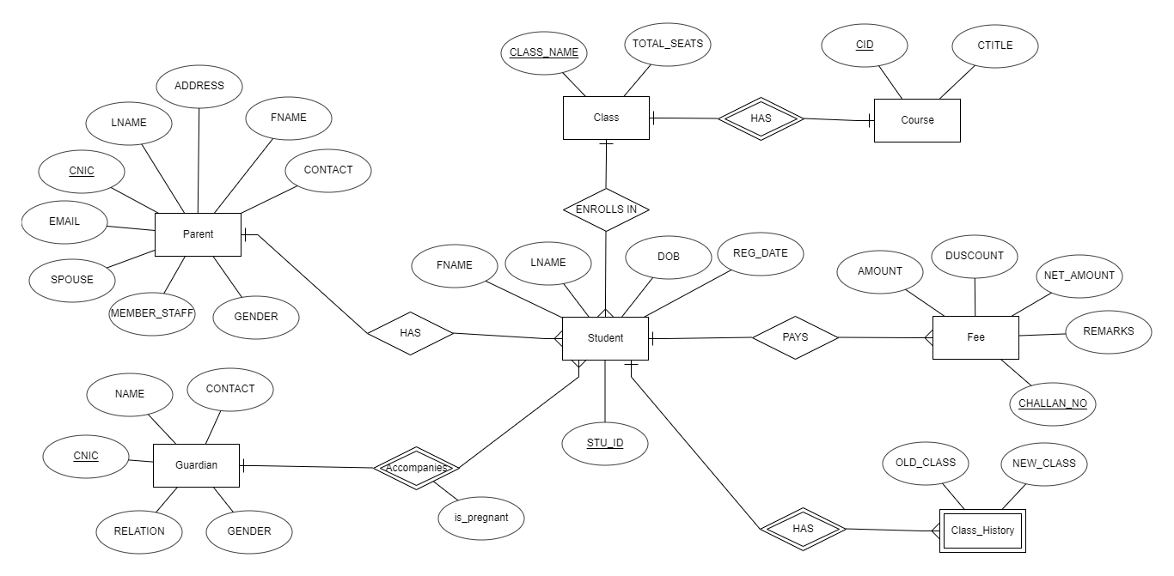

**SCHEMA DIAGRAM:** 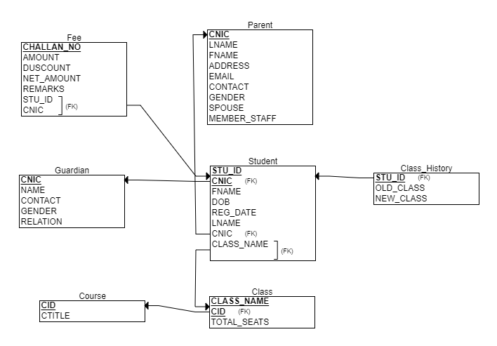

**TABLES DESCRIPTION:**

# Class:

|  |  |  |  |  |
| --- | --- | --- | --- | --- |
| **Columns Name** | **Description** | **Type/Constraints** | **Data Type** | **Details** |
| Class_Name | Class name | NULL | VARCHAR2(3) | Primary Key |
| Total_Seats | Total number of seats in the class | NULL | Number(2,10) | Identify total seats in class |
| CID | Course identifier | FK | VARCHAR2(5) | Course being taught in specific class |

# Class_History:

|  |  |  |  |  |
| --- | --- | --- | --- | --- |
| **Columns Name** | **Description** | **Type/Constraints** | **Data Type** | **Details** |
| STU_ID | Student identifier | COMPOSITE | VARCHAR2(8) | Ref. Stu_ID.Student |
| SERIAL_NO | Serial number of the record | COMPOSITE | NUMBER(11,0) | Because dependent table |
| OLD_CLASS | Previous Class |  | VARCHAR2(3) | Specify old class |
| NEW_CLASS | Shifted Class |  | VARCHAR2(3) | Specify new class |

# Course:

|  |  |  |  |  |
| --- | --- | --- | --- | --- |
| **Columns Name** | **Description** | **Type/Constraints** | **Data Type** | **Details** |
| CID | Course Identifier | PK | VARCHAR2(5) | Primary Key |
| CTITLE | Course Title | NULL | VARCHAR2(50) | Course Name |

# Guardian:

|  |  |  |  |  |
| --- | --- | --- | --- | --- |
| **Columns Name** | **Description** | **Type** | **Data Type** | **Details** |
| CNIC | Identifier | PK, U | NUMBER(13,0) | Primary Key |
| NAME | Name of the person | NULL | VARCHAR2(50) | To store Name |
| CONTACT | Contact of the person | NULL | NUMBER(11,0) | To store number |
| GENDER | Gender of the person | NULL | CHAR(1) | Gender info |
| RELATION | Relation with the student | NULL | VARCHAR2(15) | Relation |

# Parent:

|  |  |  |  |  |
| --- | --- | --- | --- | --- |
| **Columns Name** | **Description** | **Type/Constraints** | **Data Type** | **Details** |
| CNIC | Identifier | PK | NUMBER(13,0) | Primary Key |
| FNAME | First name of the parent | NULL | VARCHAR2(20) | To store first Name |
| LNAME | Last name of the parent | NULL | VARCHAR2(50) | To store last Name |
| CONTACT | Contact of the parent | NULL | NUMBER(11) | Store Number |
| GENDER | Gender of the parent | NULL | CHAR(1) | Gender info |
| EMAIL | Email address of the parent | NULL | VARCHAR2(50) | To store Email |
| SPOUSE | Spouse Identifier | FK | NUMBER(13,0) | Ref.PARENT.CNIC |
| MEMBER_STAFF | Boolean whether the parent is a member of staff or not | NULL | NUMBER(1,0) | If parent works in school or not |

# Student:

|  |  |  |  |  |
| --- | --- | --- | --- | --- |
| **Columns Name** | **Description** | **Type/Constraints** | **Data Type** | **Details** |
| STU_ID | Student Identifier | PK | VARCHAR2(8) | Primary Key |
| FNAME | First name of the student | NULL | VARCHAR2(20) | To store first name |
| LNAME | Last name of the student | NULL | VARCHAR2(20) | To store last name |
| DOB | Date of Birth of the student | NULL | DATE | To store date of birth |
| GENDER | Gender of the student | NULL | CHAR(1) | Gender Info |
| FATHER_CNIC | Identifier of the father | FK | NUMBER(13,0) | Ref.PARENT.CNIC |
| GUARDIAN_CNIC | Identifier of the guardian | FK | NUMBER(13,0) | Ref.GUARDIAN.CNIC |
| REG_DATE | Registration date | NULL | DATE | To store registration date |
| CLASSNAME | Current Class name of the Student along with the section | FK | VARCHAR2(3) | Ref.CLASS.CLASS_NAME |
| STU_IMAGE | Image identifier | NULL | VARCHAR2(100) | To store image |

# Fee:

|  |  |  |  |  |
| --- | --- | --- | --- | --- |
| **Columns Name** | **Description** | **Type/Constraints** | **Data Type** | **Details** |
| CHALLAN_NO | Challan Identifier | PK | NUMBER(10,0) | Primary Key |
| AMOUNT | Amount of the fees | NULL | NUMBER(5,0) | Fee to be paid |
| DISCOUNT | Discount given |  | NUMBER(5,0) | Discount |
| NET_AMOUNT | Total amount to be paid | NULL | NUMBER(5,0) | Total fee after discount |
| REMARKS | Remarks of the fee |  | VARCHAR2(200) | Remarks if any |
| STU_ID | Student Identifier | FK | VARCHAR2(8) | Ref.STUDENT.STU_ID |

**DATA SET:**

**Full data set is available on following google sheet link:**

<https://docs.google.com/spreadsheets/d/1JUcqnzas_Qw1l8II-qHOfbjjZPTRvjSyXd2A65YsITY/edit#gid=1284581355>

**Only Partial shown here for all tables:**

**PARENT:**

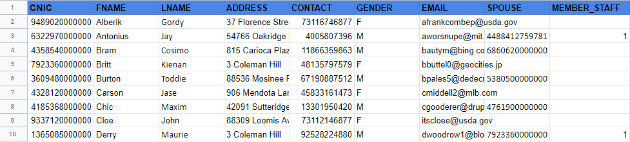

**GUARDIAN:**

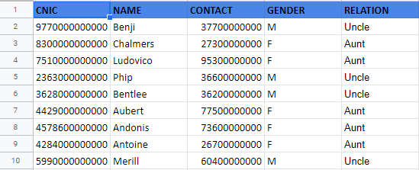

**STUDENT:**

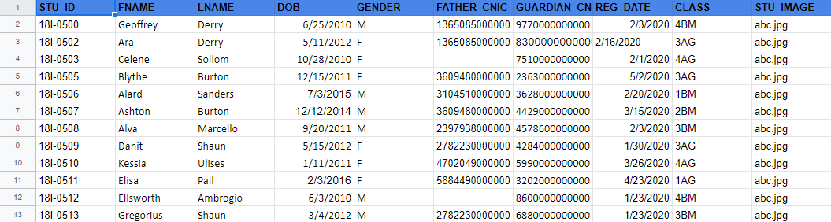

**ACCOMAPNIES: COUSE:**

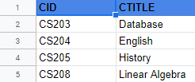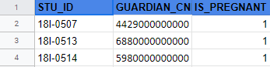

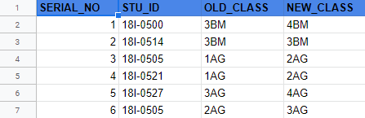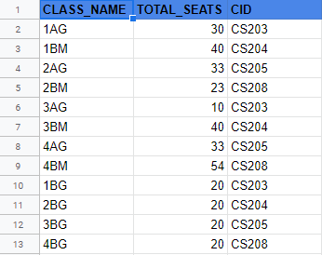**CLASS: CLASS_HISTORY:**

**FEE:**

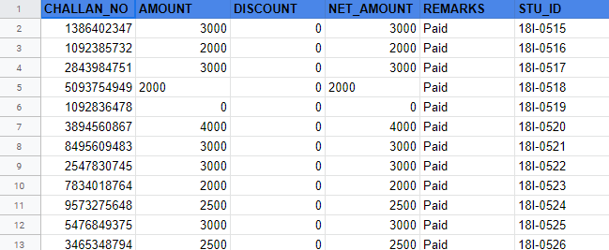

**TABLES:**

CREATE TABLE PARENT(

   CNIC NUMBER(13),

FNAME VARCHAR2(20) NOT NULL,

LNAME VARCHAR2(20),

ADDRESS VARCHAR2(50),

CONTACT NUMBER(11) NOT NULL,

GENDER CHAR(1),

EMAIL VARCHAR2(50) UNIQUE,

SPOUSE NUMBER(13),

   MEMBER_STAFF NUMBER (1)

);

CREATE TABLE GUARDIAN(

CNIC NUMBER(13),

NAME VARCHAR2(50) NOT NULL,

CONTACT NUMBER(11) NOT NULL,

GENDER CHAR(1),

  RELATION VARCHAR2(15) NOT NULL

);

CREATE TABLE Course (

CID VARCHAR2(5),

CTITLE VARCHAR2(50) NOT NULL

);

CREATE TABLE STUDENT (

STU_ID VARCHAR2(8),

FNAME VARCHAR2(20) NOT NULL,

LNAME VARCHAR2(20),

DOB DATE,

GENDER CHAR(1),

   FATHER_CNIC NUMBER(13),

GUARDIAN_CNIC NUMBER(13),

REG_DATE DATE,

CLASSNAME VARCHAR2(3),

STU_IMAGE VARCHAR(10)

   );

CREATE TABLE ACCOMPANIES(

STU_ID VARCHAR2(8),

GUARDIAN_CNIC NUMBER(13),

IS_PREGNANT NUMBER(1)

);

CREATE TABLE CLASS(

CLASS_NAME VARCHAR2(3),

TOTAL_SEATS NUMBER(2),

CID VARCHAR2(5)

);

CREATE TABLE CLASS_HISTORY(

SERIAL_NO NUMBER(11),

STU_ID VARCHAR2(8),

OLD_CLASS VARCHAR2(3) NOT NULL,

NEW_CLASS VARCHAR2(3) NOT NULL

);

CREATE TABLE FEE(

CHALLAN_NO NUMBER (10),

AMOUNT NUMBER(5),

DISCOUNT NUMBER(5),

NET_AMOUNT NUMBER(5),

REMARKS VARCHAR2(50),

STU_ID VARCHAR2(8)

);

**ALTER TABLE (FOREIGN,PRIMARY KEYS):**

ALTER TABLE PARENT

ADD CONSTRAINT pk_parent_cnic

PRIMARY KEY (CNIC);

ALTER TABLE PARENT

ADD CONSTRAINT ref_key_spouse

FOREIGN KEY (SPOUSE)

REFERENCES PARENT(CNIC);

ALTER TABLE GUARDIAN

ADD CONSTRAINT pk_guardian_cnic

PRIMARY KEY (CNIC);

alter table CLASS

ADD CONSTRAINTS pk_class_name

PRIMARY KEY(CLASS_NAME);

ALTER TABLE STUDENT

ADD CONSTRAINT pk_stu_id

PRIMARY KEY (STU_ID);

ALTER TABLE STUDENT

ADD CONSTRAINT fk_father_id

FOREIGN KEY (FATHER_CNIC)

REFERENCES PARENT(CNIC);

ALTER TABLE STUDENT

ADD CONSTRAINT fk_guardian_id

FOREIGN KEY (GUARDIAN_CNIC)

REFERENCES GUARDIAN(CNIC);

ALTER TABLE STUDENT

ADD CONSTRAINT fk_class_name

FOREIGN KEY (CLASSNAME)

REFERENCES CLASS(CLASS_NAME);

ALTER TABLE Course

ADD CONSTRAINT pk_course_id

PRIMARY KEY (CID);

alter table CLASS

ADD CONSTRAINTS fk_course_id

FOREIGN KEY(CID)

REFERENCES COURSE(CID);

alter table CLASS_HISTORY

ADD CONSTRAINTS pk_stu_id_sr_no

PRIMARY KEY(STU_ID,SERIAL_NO);

ALTER TABLE FEE

add constraints pk_challan_no

PRIMARY KEY(CHALLAN_NO);

ALTER TABLE FEE

add constraints fk_student_id

FOREIGN KEY(STU_ID)

REFERENCES STUDENT(STU_ID);

alter table ACCOMPANIES

ADD CONSTRAINTS pk_stu_id_g_cnic

PRIMARY KEY(STU_ID, GUARDIAN_CNIC);

**INSERT STATEMENTS:**

**GAURDIAN:**

INSERT INTO GUARDIAN (CNIC, NAME, CONTACT, GENDER, RELATION) VALUES (9770000000000, 'Benji', 37700000000, 'M', 'Uncle');

INSERT INTO GUARDIAN (CNIC, NAME, CONTACT, GENDER, RELATION) VALUES (8300000000000, 'Chalmers', 27300000000, 'F', 'Aunt');

INSERT INTO GUARDIAN (CNIC, NAME, CONTACT, GENDER, RELATION) VALUES (7510000000000, 'Ludovico', 95300000000, 'F', 'Aunt');

INSERT INTO GUARDIAN (CNIC, NAME, CONTACT, GENDER, RELATION) VALUES (2363000000000, 'Phip', 36600000000, 'M', 'Uncle');

INSERT INTO GUARDIAN (CNIC, NAME, CONTACT, GENDER, RELATION) VALUES (3628000000000, 'Bentlee', 36200000000, 'M', 'Uncle');

INSERT INTO GUARDIAN (CNIC, NAME, CONTACT, GENDER, RELATION) VALUES (4429000000000, 'Aubert', 77500000000, 'F', 'Aunt');

INSERT INTO GUARDIAN (CNIC, NAME, CONTACT, GENDER, RELATION) VALUES (4578600000000, 'Andonis', 73600000000, 'F', 'Aunt');

INSERT INTO GUARDIAN (CNIC, NAME, CONTACT, GENDER, RELATION) VALUES (4284000000000, 'Antoine', 26700000000, 'F', 'Aunt');

INSERT INTO GUARDIAN (CNIC, NAME, CONTACT, GENDER, RELATION) VALUES (5990000000000, 'Merill', 60400000000, 'M', 'Uncle');

INSERT INTO GUARDIAN (CNIC, NAME, CONTACT, GENDER, RELATION) VALUES (3202000000000, 'Clyve', 14400000000, 'F', 'Aunt');

INSERT INTO GUARDIAN (CNIC, NAME, CONTACT, GENDER, RELATION) VALUES (8600000000000, 'Quentin', 31500000000, 'M', 'Uncle');

INSERT INTO GUARDIAN (CNIC, NAME, CONTACT, GENDER, RELATION) VALUES (6880000000000, 'Dino', 95900000000, 'F', 'Aunt');

INSERT INTO GUARDIAN (CNIC, NAME, CONTACT, GENDER, RELATION) VALUES (5980000000000, 'Immanuel', 68800000000, 'M', 'Uncle');

INSERT INTO GUARDIAN (CNIC, NAME, CONTACT, GENDER, RELATION) VALUES (9180000000000, 'Van', 66700000000, 'F', 'Aunt');

INSERT INTO GUARDIAN (CNIC, NAME, CONTACT, GENDER, RELATION) VALUES (4740000000000, 'Lars', 42400000000, 'M', 'Uncle');

INSERT INTO GUARDIAN (CNIC, NAME, CONTACT, GENDER, RELATION) VALUES (7360000000000, 'Dimitry', 33000000000, 'M', 'Uncle');

INSERT INTO GUARDIAN (CNIC, NAME, CONTACT, GENDER, RELATION) VALUES (7320000000000, 'Gunner', 55800000000, 'F', 'Aunt');

INSERT INTO GUARDIAN (CNIC, NAME, CONTACT, GENDER, RELATION) VALUES (8450000000000, 'Sheffy', 44200000000, 'F', 'Aunt');

INSERT INTO GUARDIAN (CNIC, NAME, CONTACT, GENDER, RELATION) VALUES (9620000000000, 'Rollo', 52391000000, 'M', 'Uncle');

INSERT INTO GUARDIAN (CNIC, NAME, CONTACT, GENDER, RELATION) VALUES (4800000000000, 'Tibold', 36200000000, 'F', 'Aunt');

INSERT INTO GUARDIAN (CNIC, NAME, CONTACT, GENDER, RELATION) VALUES (9610000000000, 'Grace', 16800000000, 'F', 'Aunt');

INSERT INTO GUARDIAN (CNIC, NAME, CONTACT, GENDER, RELATION) VALUES (2930000000000, 'Joe', 39700000000, 'M', 'Uncle');

INSERT INTO GUARDIAN (CNIC, NAME, CONTACT, GENDER, RELATION) VALUES (6770000000000, 'Marwin', 88200000000, 'M', 'Uncle');

INSERT INTO GUARDIAN (CNIC, NAME, CONTACT, GENDER, RELATION) VALUES (4440000000000, 'Brok', 65600000000, 'M', 'Uncle');

INSERT INTO GUARDIAN (CNIC, NAME, CONTACT, GENDER, RELATION) VALUES (5320000000000, 'Hazel', 70200000000, 'F', 'Aunt');

INSERT INTO GUARDIAN (CNIC, NAME, CONTACT, GENDER, RELATION) VALUES (8160000000000, 'Giffy', 78000000000, 'F', 'Aunt');

INSERT INTO GUARDIAN (CNIC, NAME, CONTACT, GENDER, RELATION) VALUES (3140000000000, 'Morey', 13900000000, 'M', 'Uncle');

INSERT INTO GUARDIAN (CNIC, NAME, CONTACT, GENDER, RELATION) VALUES (6850000000000, 'Terry', 85500000000, 'F', 'Aunt');

INSERT INTO GUARDIAN (CNIC, NAME, CONTACT, GENDER, RELATION) VALUES (2240000000000, 'Noach', 70800000000, 'M', 'Uncle');

INSERT INTO GUARDIAN (CNIC, NAME, CONTACT, GENDER, RELATION) VALUES (3570000000000, 'Phillipe', 31860000000, 'M', 'Uncle');

**COURSE:**

INSERT INTO COURSE (CID, CTITLE) VALUES ('CS203', 'Database');

INSERT INTO COURSE (CID, CTITLE) VALUES ('CS204', 'English');

INSERT INTO COURSE (CID, CTITLE) VALUES ('CS205', 'History');

INSERT INTO COURSE (CID, CTITLE) VALUES ('CS208', 'Linear Algebra');

**CLASS:**

Insert into CLASS (CLASS_NAME,TOTAL_SEATS,CID) values ('1AG',30,'CS203');

Insert into CLASS (CLASS_NAME,TOTAL_SEATS,CID) values ('1BM',40,'CS204');

Insert into CLASS (CLASS_NAME,TOTAL_SEATS,CID) values ('2AG',33,'CS205');

Insert into CLASS (CLASS_NAME,TOTAL_SEATS,CID) values ('2BM',23,'CS208');

Insert into CLASS (CLASS_NAME,TOTAL_SEATS,CID) values ('3AG',10,'CS203');

Insert into CLASS (CLASS_NAME,TOTAL_SEATS,CID) values ('3BM',40,'CS204');

Insert into CLASS (CLASS_NAME,TOTAL_SEATS,CID) values ('4AG',33,'CS205');

Insert into CLASS (CLASS_NAME,TOTAL_SEATS,CID) values ('4BM',54,'CS208');

Insert into CLASS (CLASS_NAME,TOTAL_SEATS,CID) values ('1BG',20,'CS203');

Insert into CLASS (CLASS_NAME,TOTAL_SEATS,CID) values ('2BG',20,'CS204');

Insert into CLASS (CLASS_NAME,TOTAL_SEATS,CID) values ('3BG',20,'CS205');

Insert into CLASS (CLASS_NAME,TOTAL_SEATS,CID) values ('4BG',20,'CS208');

**PARENT:**

Insert into PARENT (CNIC,FNAME,LNAME,ADDRESS,CONTACT,GENDER,EMAIL,SPOUSE,MEMBER_STAFF) values (7923360000000,'Britt','Kienan','3 Coleman Hill',48135797579,'F','bbuttel0@geocities.jp',null,null);

Insert into PARENT (CNIC,FNAME,LNAME,ADDRESS,CONTACT,GENDER,EMAIL,SPOUSE,MEMBER_STAFF) values (4328120000000,'Carson','Jase','906 Mendota Lane',45833161473,'F','cmiddell2@mlb.com',null,null);

Insert into PARENT (CNIC,FNAME,LNAME,ADDRESS,CONTACT,GENDER,EMAIL,SPOUSE,MEMBER_STAFF) values (5380500000000,'Stevy','Tye','88536 Mosinee Place',62421840538,'F','stezure3@aboutads.info',null,null);

Insert into PARENT (CNIC,FNAME,LNAME,ADDRESS,CONTACT,GENDER,EMAIL,SPOUSE,MEMBER_STAFF) values (1099270000000,'Kane','Barthel','0 Esker Street',3590976408,'F','kbricklebanka@lycos.com',null,null);

Insert into PARENT (CNIC,FNAME,LNAME,ADDRESS,CONTACT,GENDER,EMAIL,SPOUSE,MEMBER_STAFF) values (4886610000000,'Giorgi','Osmund','78534 Derek Parkway',74721892038,'F','gpetrenb@seesaa.net',null,null);

Insert into PARENT (CNIC,FNAME,LNAME,ADDRESS,CONTACT,GENDER,EMAIL,SPOUSE,MEMBER_STAFF) values (2530740000000,'Kingsly','Tristan','6 Schiller Pass',90533988578,'F','kstegerc@nature.com',null,null);

Insert into PARENT (CNIC,FNAME,LNAME,ADDRESS,CONTACT,GENDER,EMAIL,SPOUSE,MEMBER_STAFF) values (3932250000000,'Fidelio','Clerc','925 Havey Terrace',13436556045,'F','fsimmankd@goo.ne.jp',null,null);

Insert into PARENT (CNIC,FNAME,LNAME,ADDRESS,CONTACT,GENDER,EMAIL,SPOUSE,MEMBER_STAFF) values (4488412759781,'Karel','Zachery','54766 Oakridge Place',63147363348,'F','kshimmansg@de.vu',null,null);

Insert into PARENT (CNIC,FNAME,LNAME,ADDRESS,CONTACT,GENDER,EMAIL,SPOUSE,MEMBER_STAFF) values (3076160000000,'Pebrook','Freemon','04 Waywood Parkway',10215007221,'F','pmcteari@mysql.com',null,null);

Insert into PARENT (CNIC,FNAME,LNAME,ADDRESS,CONTACT,GENDER,EMAIL,SPOUSE,MEMBER_STAFF) values (3620580000000,'Maxie','Dylan','8068 Almo Court',44719964219,'F','mpedrolj@examiner.com',null,null);

Insert into PARENT (CNIC,FNAME,LNAME,ADDRESS,CONTACT,GENDER,EMAIL,SPOUSE,MEMBER_STAFF) values (4761900000000,'Jeth','Allin','42091 Sutteridge Avenue',49549184173,'F','jfettersk@shop-pro.jp',null,null);

Insert into PARENT (CNIC,FNAME,LNAME,ADDRESS,CONTACT,GENDER,EMAIL,SPOUSE,MEMBER_STAFF) values (2024270000000,'Zollie','Courtnay','89886 Center Terrace',38607437903,'F','zwarbysn@apache.org',null,null);

Insert into PARENT (CNIC,FNAME,LNAME,ADDRESS,CONTACT,GENDER,EMAIL,SPOUSE,MEMBER_STAFF) values (6860620000000,'Gino','Archer','815 Carioca Plaza',93548802101,'F','gbartolomieuo@bloglovin.com',null,null);

Insert into PARENT (CNIC,FNAME,LNAME,ADDRESS,CONTACT,GENDER,EMAIL,SPOUSE,MEMBER_STAFF) values (9489020000000,'Alberik','Gordy','37 Florence Street',73116746877,'F','afrankcombep@usda.gov',null,null);

Insert into PARENT (CNIC,FNAME,LNAME,ADDRESS,CONTACT,GENDER,EMAIL,SPOUSE,MEMBER_STAFF) values (9337120000000,'Cloe','John','88309 Loomis Avenue',73112146877,'F','itscloee@usda.gov',null,null);

Insert into PARENT (CNIC,FNAME,LNAME,ADDRESS,CONTACT,GENDER,EMAIL,SPOUSE,MEMBER_STAFF) values (9159010000000,'Zoe','Berlin','11352 Gulseth Point',73116726017,'F','zoebarnes@usda.gov',null,null);

Insert into PARENT (CNIC,FNAME,LNAME,ADDRESS,CONTACT,GENDER,EMAIL,SPOUSE,MEMBER_STAFF) values (1365085000000,'Derry','Maurie','3 Coleman Hill',92528224880,'M','dwoodrow1@blogspot.com',7923360000000,null);

Insert into PARENT (CNIC,FNAME,LNAME,ADDRESS,CONTACT,GENDER,EMAIL,SPOUSE,MEMBER_STAFF) values (3104510000000,'Sanders','Clementius','906 Mendota Lane',21972676266,'M','sgergher4@hugedomains.com',4328120000000,1);

Insert into PARENT (CNIC,FNAME,LNAME,ADDRESS,CONTACT,GENDER,EMAIL,SPOUSE,MEMBER_STAFF) values (3609480000000,'Burton','Toddie','88536 Mosinee Place',67190887512,'M','bpales5@dedecms.com',5380500000000,null);

Insert into PARENT (CNIC,FNAME,LNAME,ADDRESS,CONTACT,GENDER,EMAIL,SPOUSE,MEMBER_STAFF) values (2397938000000,'Marcello','Giraldo','0 Esker Street',53587090057,'M','mbison6@webnode.com',1099270000000,null);

Insert into PARENT (CNIC,FNAME,LNAME,ADDRESS,CONTACT,GENDER,EMAIL,SPOUSE,MEMBER_STAFF) values (2782230000000,'Shaun','Fredric','78534 Derek Parkway',77428173972,'M','skinloch7@facebook.com',4886610000000,null);

Insert into PARENT (CNIC,FNAME,LNAME,ADDRESS,CONTACT,GENDER,EMAIL,SPOUSE,MEMBER_STAFF) values (4702049000000,'Ulises','Theodore','6 Schiller Pass',58531803606,'M','ufillan8@bloglines.com',2530740000000,null);

Insert into PARENT (CNIC,FNAME,LNAME,ADDRESS,CONTACT,GENDER,EMAIL,SPOUSE,MEMBER_STAFF) values (5884490000000,'Pail','Murray','925 Havey Terrace',11132476970,'M','post9@indiatimes.com',3932250000000,null);

Insert into PARENT (CNIC,FNAME,LNAME,ADDRESS,CONTACT,GENDER,EMAIL,SPOUSE,MEMBER_STAFF) values (6322970000000,'Antonius','Jay','54766 Oakridge Place',4005807396,'M','aworsnupe@mit.edu',4488412759781,null);

Insert into PARENT (CNIC,FNAME,LNAME,ADDRESS,CONTACT,GENDER,EMAIL,SPOUSE,MEMBER_STAFF) values (7037140000000,'Otes','Brit','04 Waywood Parkway',90739480287,'M','oblevinf@imdb.com',3076160000000,null);

Insert into PARENT (CNIC,FNAME,LNAME,ADDRESS,CONTACT,GENDER,EMAIL,SPOUSE,MEMBER_STAFF) values (4752490000000,'Willi','Gilberto','8068 Almo Court',11059752136,'M','wtrippetth@weather.com',3620580000000,1);

Insert into PARENT (CNIC,FNAME,LNAME,ADDRESS,CONTACT,GENDER,EMAIL,SPOUSE,MEMBER_STAFF) values (2173060000000,'Ogdan','Gav','89886 Center Terrace',80209670023,'M','oskasel@examiner.com',2024270000000,null);

Insert into PARENT (CNIC,FNAME,LNAME,ADDRESS,CONTACT,GENDER,EMAIL,SPOUSE,MEMBER_STAFF) values (4358540000000,'Bram','Cosimo','815 Carioca Plaza',11866359863,'M','bautym@bing.com',6860620000000,null);

Insert into PARENT (CNIC,FNAME,LNAME,ADDRESS,CONTACT,GENDER,EMAIL,SPOUSE,MEMBER_STAFF) values (5233600000000,'Sherman','Hardy','37 Florence Street',88489520728,'M','sdeleaq@phoca.cz',9489020000000,1);

Insert into PARENT (CNIC,FNAME,LNAME,ADDRESS,CONTACT,GENDER,EMAIL,SPOUSE,MEMBER_STAFF) values (4185368000000,'Chic','Maxim','42091 Sutteridge Avenue',13301950420,'M','cgooderer@drupal.org',4761900000000,null);

Insert into PARENT (CNIC,FNAME,LNAME,ADDRESS,CONTACT,GENDER,EMAIL,SPOUSE,MEMBER_STAFF) values (2853910000000,'Levi','Winnie','88309 Loomis Avenue',24053885401,'M','lfallenss@foxnews.com',9337120000000,null);

Insert into PARENT (CNIC,FNAME,LNAME,ADDRESS,CONTACT,GENDER,EMAIL,SPOUSE,MEMBER_STAFF) values (4530940000000,'Paddie','Teddie','11352 Gulseth Point',20861607466,'M','proxburght@sphinn.com',9159010000000,null);

**STUDENT:**

Insert into STUDENT (STU_ID,FNAME,LNAME,DOB,GENDER,FATHER_CNIC,GUARDIAN_CNIC,REG_DATE,CLASSNAME,STU_IMAGE) values ('18I-0500','Geoffrey','Derry',to_timestamp('25-JUN-10','DD-MON-RR HH.MI.SSXFF AM'),'M',1365085000000,9770000000000,to_timestamp('03-FEB-20','DD-MON-RR HH.MI.SSXFF AM'),'4BM','abc.jpg');

Insert into STUDENT (STU_ID,FNAME,LNAME,DOB,GENDER,FATHER_CNIC,GUARDIAN_CNIC,REG_DATE,CLASSNAME,STU_IMAGE) values ('18I-0502','Ara','Derry',to_timestamp('11-MAY-12','DD-MON-RR HH.MI.SSXFF AM'),'F',1365085000000,8300000000000,to_timestamp('16-FEB-20','DD-MON-RR HH.MI.SSXFF AM'),'3AG','abc.jpg');

Insert into STUDENT (STU_ID,FNAME,LNAME,DOB,GENDER,FATHER_CNIC,GUARDIAN_CNIC,REG_DATE,CLASSNAME,STU_IMAGE) values ('18I-0503','Celene','Sollom',to_timestamp('28-OCT-10','DD-MON-RR HH.MI.SSXFF AM'),'F',null,7510000000000,to_timestamp('01-FEB-20','DD-MON-RR HH.MI.SSXFF AM'),'4AG','abc.jpg');

Insert into STUDENT (STU_ID,FNAME,LNAME,DOB,GENDER,FATHER_CNIC,GUARDIAN_CNIC,REG_DATE,CLASSNAME,STU_IMAGE) values ('18I-0505','Blythe','Burton',to_timestamp('15-DEC-11','DD-MON-RR HH.MI.SSXFF AM'),'F',3609480000000,2363000000000,to_timestamp('02-MAY-20','DD-MON-RR HH.MI.SSXFF AM'),'3AG','abc.jpg');

Insert into STUDENT (STU_ID,FNAME,LNAME,DOB,GENDER,FATHER_CNIC,GUARDIAN_CNIC,REG_DATE,CLASSNAME,STU_IMAGE) values ('18I-0506','Alard','Sanders',to_timestamp('03-JUL-15','DD-MON-RR HH.MI.SSXFF AM'),'M',3104510000000,3628000000000,to_timestamp('20-FEB-20','DD-MON-RR HH.MI.SSXFF AM'),'1BM','abc.jpg');

Insert into STUDENT (STU_ID,FNAME,LNAME,DOB,GENDER,FATHER_CNIC,GUARDIAN_CNIC,REG_DATE,CLASSNAME,STU_IMAGE) values ('18I-0507','Ashton','Burton',to_timestamp('12-DEC-14','DD-MON-RR HH.MI.SSXFF AM'),'M',3609480000000,4429000000000,to_timestamp('15-MAR-20','DD-MON-RR HH.MI.SSXFF AM'),'2BM','abc.jpg');

Insert into STUDENT (STU_ID,FNAME,LNAME,DOB,GENDER,FATHER_CNIC,GUARDIAN_CNIC,REG_DATE,CLASSNAME,STU_IMAGE) values ('18I-0508','Alva','Marcello',to_timestamp('20-SEP-11','DD-MON-RR HH.MI.SSXFF AM'),'M',2397938000000,4578600000000,to_timestamp('03-FEB-20','DD-MON-RR HH.MI.SSXFF AM'),'3BM','abc.jpg');

Insert into STUDENT (STU_ID,FNAME,LNAME,DOB,GENDER,FATHER_CNIC,GUARDIAN_CNIC,REG_DATE,CLASSNAME,STU_IMAGE) values ('18I-0509','Danit','Shaun',to_timestamp('15-MAY-12','DD-MON-RR HH.MI.SSXFF AM'),'F',2782230000000,4284000000000,to_timestamp('30-JAN-20','DD-MON-RR HH.MI.SSXFF AM'),'3AG','abc.jpg');

Insert into STUDENT (STU_ID,FNAME,LNAME,DOB,GENDER,FATHER_CNIC,GUARDIAN_CNIC,REG_DATE,CLASSNAME,STU_IMAGE) values ('18I-0510','Kessia','Ulises',to_timestamp('11-JAN-11','DD-MON-RR HH.MI.SSXFF AM'),'F',4702049000000,5990000000000,to_timestamp('26-MAR-20','DD-MON-RR HH.MI.SSXFF AM'),'4AG','abc.jpg');

Insert into STUDENT (STU_ID,FNAME,LNAME,DOB,GENDER,FATHER_CNIC,GUARDIAN_CNIC,REG_DATE,CLASSNAME,STU_IMAGE) values ('18I-0511','Elisa','Paili',to_timestamp('03-FEB-16','DD-MON-RR HH.MI.SSXFF AM'),'F',5884490000000,3202000000000,to_timestamp('23-APR-20','DD-MON-RR HH.MI.SSXFF AM'),'1AG','abc.jpg');

Insert into STUDENT (STU_ID,FNAME,LNAME,DOB,GENDER,FATHER_CNIC,GUARDIAN_CNIC,REG_DATE,CLASSNAME,STU_IMAGE) values ('18I-0512','Ellsworth','Ambrogio',to_timestamp('03-JUN-10','DD-MON-RR HH.MI.SSXFF AM'),'M',null,8600000000000,to_timestamp('23-JAN-20','DD-MON-RR HH.MI.SSXFF AM'),'4BM','abc.jpg');

Insert into STUDENT (STU_ID,FNAME,LNAME,DOB,GENDER,FATHER_CNIC,GUARDIAN_CNIC,REG_DATE,CLASSNAME,STU_IMAGE) values ('18I-0513','Gregorius','Shaun',to_timestamp('04-MAR-12','DD-MON-RR HH.MI.SSXFF AM'),'M',2782230000000,6880000000000,to_timestamp('23-JAN-20','DD-MON-RR HH.MI.SSXFF AM'),'3BM','abc.jpg');

Insert into STUDENT (STU_ID,FNAME,LNAME,DOB,GENDER,FATHER_CNIC,GUARDIAN_CNIC,REG_DATE,CLASSNAME,STU_IMAGE) values ('18I-0514','Derril','Ulises',to_timestamp('28-FEB-12','DD-MON-RR HH.MI.SSXFF AM'),'M',4702049000000,5980000000000,to_timestamp('23-JAN-20','DD-MON-RR HH.MI.SSXFF AM'),'3BM','abc.jpg');

Insert into STUDENT (STU_ID,FNAME,LNAME,DOB,GENDER,FATHER_CNIC,GUARDIAN_CNIC,REG_DATE,CLASSNAME,STU_IMAGE) values ('18I-0515','Karin','Pail',to_timestamp('28-APR-11','DD-MON-RR HH.MI.SSXFF AM'),'F',5884490000000,9180000000000,to_timestamp('03-FEB-20','DD-MON-RR HH.MI.SSXFF AM'),'4AG','abc.jpg');

Insert into STUDENT (STU_ID,FNAME,LNAME,DOB,GENDER,FATHER_CNIC,GUARDIAN_CNIC,REG_DATE,CLASSNAME,STU_IMAGE) values ('18I-0517','Bordie','Otes',to_timestamp('14-JAN-12','DD-MON-RR HH.MI.SSXFF AM'),'M',7037140000000,7360000000000,to_timestamp('03-FEB-20','DD-MON-RR HH.MI.SSXFF AM'),'3BM','abc.jpg');

Insert into STUDENT (STU_ID,FNAME,LNAME,DOB,GENDER,FATHER_CNIC,GUARDIAN_CNIC,REG_DATE,CLASSNAME,STU_IMAGE) values ('18I-0518','Marlyn','Antonius',to_timestamp('06-FEB-12','DD-MON-RR HH.MI.SSXFF AM'),'F',6322970000000,7320000000000,to_timestamp('23-JAN-20','DD-MON-RR HH.MI.SSXFF AM'),'3AG','abc.jpg');

Insert into STUDENT (STU_ID,FNAME,LNAME,DOB,GENDER,FATHER_CNIC,GUARDIAN_CNIC,REG_DATE,CLASSNAME,STU_IMAGE) values ('18I-0519','Andria','Willi',to_timestamp('15-MAY-11','DD-MON-RR HH.MI.SSXFF AM'),'F',4752490000000,8450000000000,to_timestamp('03-APR-20','DD-MON-RR HH.MI.SSXFF AM'),'4AG','abc.jpg');

Insert into STUDENT (STU_ID,FNAME,LNAME,DOB,GENDER,FATHER_CNIC,GUARDIAN_CNIC,REG_DATE,CLASSNAME,STU_IMAGE) values ('18I-0520','Lucho','Otes',to_timestamp('07-JAN-11','DD-MON-RR HH.MI.SSXFF AM'),'M',7037140000000,9620000000000,to_timestamp('22-MAR-20','DD-MON-RR HH.MI.SSXFF AM'),'4BM','abc.jpg');

Insert into STUDENT (STU_ID,FNAME,LNAME,DOB,GENDER,FATHER_CNIC,GUARDIAN_CNIC,REG_DATE,CLASSNAME,STU_IMAGE) values ('18I-0521','Kathryne','Willi',to_timestamp('05-AUG-14','DD-MON-RR HH.MI.SSXFF AM'),'F',4752490000000,4800000000000,to_timestamp('21-MAR-20','DD-MON-RR HH.MI.SSXFF AM'),'2AG','abc.jpg');

Insert into STUDENT (STU_ID,FNAME,LNAME,DOB,GENDER,FATHER_CNIC,GUARDIAN_CNIC,REG_DATE,CLASSNAME,STU_IMAGE) values ('18I-0522','Roscoe','Chic',to_timestamp('25-JUN-11','DD-MON-RR HH.MI.SSXFF AM'),'M',4185368000000,9610000000000,to_timestamp('21-MAR-20','DD-MON-RR HH.MI.SSXFF AM'),'3BM','abc.jpg');

Insert into STUDENT (STU_ID,FNAME,LNAME,DOB,GENDER,FATHER_CNIC,GUARDIAN_CNIC,REG_DATE,CLASSNAME,STU_IMAGE) values ('18I-0523','Kip','Ricks',to_timestamp('20-MAR-15','DD-MON-RR HH.MI.SSXFF AM'),'M',null,2930000000000,to_timestamp('20-MAR-20','DD-MON-RR HH.MI.SSXFF AM'),'2BM','abc.jpg');

Insert into STUDENT (STU_ID,FNAME,LNAME,DOB,GENDER,FATHER_CNIC,GUARDIAN_CNIC,REG_DATE,CLASSNAME,STU_IMAGE) values ('18I-0524','Blake','Bram',to_timestamp('14-OCT-11','DD-MON-RR HH.MI.SSXFF AM'),'F',4358540000000,6770000000000,to_timestamp('21-JAN-20','DD-MON-RR HH.MI.SSXFF AM'),'3AG','abc.jpg');

Insert into STUDENT (STU_ID,FNAME,LNAME,DOB,GENDER,FATHER_CNIC,GUARDIAN_CNIC,REG_DATE,CLASSNAME,STU_IMAGE) values ('18I-0525','Wendall','Ogdan',to_timestamp('04-DEC-10','DD-MON-RR HH.MI.SSXFF AM'),'M',2173060000000,4440000000000,to_timestamp('22-FEB-20','DD-MON-RR HH.MI.SSXFF AM'),'4BM','abc.jpg');

Insert into STUDENT (STU_ID,FNAME,LNAME,DOB,GENDER,FATHER_CNIC,GUARDIAN_CNIC,REG_DATE,CLASSNAME,STU_IMAGE) values ('18I-0527','Edwina','Geard',to_timestamp('29-JUN-11','DD-MON-RR HH.MI.SSXFF AM'),'F',null,8160000000000,to_timestamp('22-MAR-19','DD-MON-RR HH.MI.SSXFF AM'),'4AG','abc.jpg');

Insert into STUDENT (STU_ID,FNAME,LNAME,DOB,GENDER,FATHER_CNIC,GUARDIAN_CNIC,REG_DATE,CLASSNAME,STU_IMAGE) values ('18I-0528','Sidonia','Keningley',to_timestamp('24-MAR-16','DD-MON-RR HH.MI.SSXFF AM'),'F',5233600000000,3140000000000,to_timestamp('13-APR-19','DD-MON-RR HH.MI.SSXFF AM'),'1AG','abc.jpg');

Insert into STUDENT (STU_ID,FNAME,LNAME,DOB,GENDER,FATHER_CNIC,GUARDIAN_CNIC,REG_DATE,CLASSNAME,STU_IMAGE) values ('18I-0529','Martainn','Chic',to_timestamp('15-APR-12','DD-MON-RR HH.MI.SSXFF AM'),'M',4185368000000,6850000000000,to_timestamp('14-FEB-19','DD-MON-RR HH.MI.SSXFF AM'),'3BM','abc.jpg');

Insert into STUDENT (STU_ID,FNAME,LNAME,DOB,GENDER,FATHER_CNIC,GUARDIAN_CNIC,REG_DATE,CLASSNAME,STU_IMAGE) values ('18I-0530','Fonz','Boundy',to_timestamp('16-JUN-11','DD-MON-RR HH.MI.SSXFF AM'),'M',2853910000000,2240000000000,to_timestamp('09-DEC-19','DD-MON-RR HH.MI.SSXFF AM'),'4BM','abc.jpg');

Insert into STUDENT (STU_ID,FNAME,LNAME,DOB,GENDER,FATHER_CNIC,GUARDIAN_CNIC,REG_DATE,CLASSNAME,STU_IMAGE) values ('18I-0534','Elita','Chic',to_timestamp('25-AUG-14','DD-MON-RR HH.MI.SSXFF AM'),'F',4185368000000,9610000000000,to_timestamp('21-MAR-20','DD-MON-RR HH.MI.SSXFF AM'),'2BM','abc.jpg');

Insert into STUDENT (STU_ID,FNAME,LNAME,DOB,GENDER,FATHER_CNIC,GUARDIAN_CNIC,REG_DATE,CLASSNAME,STU_IMAGE) values ('18I-0532','Mark','Paddie',to_timestamp('04-MAR-15','DD-MON-RR HH.MI.SSXFF AM'),'M',4530940000000,3570000000000,to_timestamp('30-OCT-19','DD-MON-RR HH.MI.SSXFF AM'),'2BM','abc.jpg');

Insert into STUDENT (STU_ID,FNAME,LNAME,DOB,GENDER,FATHER_CNIC,GUARDIAN_CNIC,REG_DATE,CLASSNAME,STU_IMAGE) values ('18I-0533','John','Paddie',to_timestamp('02-JAN-11','DD-MON-RR HH.MI.SSXFF AM'),'M',4530940000000,3570000000000,to_timestamp('30-OCT-19','DD-MON-RR HH.MI.SSXFF AM'),'4BM','abc.jpg');

Insert into STUDENT (STU_ID,FNAME,LNAME,DOB,GENDER,FATHER_CNIC,GUARDIAN_CNIC,REG_DATE,CLASSNAME,STU_IMAGE) values ('18I-0535','Chris','Willi',to_timestamp('20-AUG-12','DD-MON-RR HH.MI.SSXFF AM'),'F',4752490000000,4800000000000,to_timestamp('21-MAR-20','DD-MON-RR HH.MI.SSXFF AM'),'3BG','abc.jpg');

Insert into STUDENT (STU_ID,FNAME,LNAME,DOB,GENDER,FATHER_CNIC,GUARDIAN_CNIC,REG_DATE,CLASSNAME,STU_IMAGE) values ('18I-0536','David','Sanders',to_timestamp('12-MAR-14','DD-MON-RR HH.MI.SSXFF AM'),'M',3104510000000,3628000000000,to_timestamp('21-MAR-20','DD-MON-RR HH.MI.SSXFF AM'),'2BG','abc.jpg');

Insert into STUDENT (STU_ID,FNAME,LNAME,DOB,GENDER,FATHER_CNIC,GUARDIAN_CNIC,REG_DATE,CLASSNAME,STU_IMAGE) values ('18I-0537','Brown','Levi',to_timestamp('12-FEB-15','DD-MON-RR HH.MI.SSXFF AM'),'F',2853910000000,2240000000000,to_timestamp('21-MAR-20','DD-MON-RR HH.MI.SSXFF AM'),'2BG','abc.jpg');

Insert into STUDENT (STU_ID,FNAME,LNAME,DOB,GENDER,FATHER_CNIC,GUARDIAN_CNIC,REG_DATE,CLASSNAME,STU_IMAGE) values ('18I-0538','Harry','Levi',to_timestamp('13-MAR-14','DD-MON-RR HH.MI.SSXFF AM'),'M',2853910000000,2240000000000,to_timestamp('21-MAR-20','DD-MON-RR HH.MI.SSXFF AM'),'2BG','abc.jpg');

Insert into STUDENT (STU_ID,FNAME,LNAME,DOB,GENDER,FATHER_CNIC,GUARDIAN_CNIC,REG_DATE,CLASSNAME,STU_IMAGE) values ('18I-0539','Curly','Marcello',to_timestamp('02-FEB-17','DD-MON-RR HH.MI.SSXFF AM'),'F',2397938000000,4578600000000,to_timestamp('21-MAR-20','DD-MON-RR HH.MI.SSXFF AM'),'1BG','abc.jpg');

Insert into STUDENT (STU_ID,FNAME,LNAME,DOB,GENDER,FATHER_CNIC,GUARDIAN_CNIC,REG_DATE,CLASSNAME,STU_IMAGE) values ('18I-0540','Ying','Shaun',to_timestamp('02-MAR-16','DD-MON-RR HH.MI.SSXFF AM'),'M',2782230000000,6880000000000,to_timestamp('21-MAR-20','DD-MON-RR HH.MI.SSXFF AM'),'1BG','abc.jpg');

Insert into STUDENT (STU_ID,FNAME,LNAME,DOB,GENDER,FATHER_CNIC,GUARDIAN_CNIC,REG_DATE,CLASSNAME,STU_IMAGE) values ('18I-0531','Gunar','Paddie',to_timestamp('04-JAN-17','DD-MON-RR HH.MI.SSXFF AM'),'M',4530940000000,3570000000000,to_timestamp('15-FEB-20','DD-MON-RR HH.MI.SSXFF AM'),'1BM','abc.jpg');

**CLASS HISTORY:**

Insert into CLASS_HISTORY (SERIAL_NO,STU_ID,OLD_CLASS,NEW_CLASS) values (1,'18I-0500','3BM','4BM');

Insert into CLASS_HISTORY (SERIAL_NO,STU_ID,OLD_CLASS,NEW_CLASS) values (2,'18I-0514','3BM','3BM');

Insert into CLASS_HISTORY (SERIAL_NO,STU_ID,OLD_CLASS,NEW_CLASS) values (3,'18I-0505','1AG','2AG');

Insert into CLASS_HISTORY (SERIAL_NO,STU_ID,OLD_CLASS,NEW_CLASS) values (4,'18I-0521','1AG','2AG');

Insert into CLASS_HISTORY (SERIAL_NO,STU_ID,OLD_CLASS,NEW_CLASS) values (5,'18I-0527','3AG','4AG');

Insert into CLASS_HISTORY (SERIAL_NO,STU_ID,OLD_CLASS,NEW_CLASS) values (6,'18I-0505','2AG','3AG');

**ACCOMPANIES:**

Insert into ACCOMPANIES (STU_ID,GUARDIAN_CNIC,IS_PREGNANT) values ('18I-0507',4429000000000,1);

Insert into ACCOMPANIES (STU_ID,GUARDIAN_CNIC,IS_PREGNANT) values ('18I-0513',6880000000000,1);

Insert into ACCOMPANIES (STU_ID,GUARDIAN_CNIC,IS_PREGNANT) values ('18I-0514',5980000000000,1);

**FEE:**

Insert into FEE (CHALLAN_NO,AMOUNT,DISCOUNT,NET_AMOUNT,REMARKS,STU_ID) values (1386402347,3000,0,3000,'Paid','18I-0515');

Insert into FEE (CHALLAN_NO,AMOUNT,DISCOUNT,NET_AMOUNT,REMARKS,STU_ID) values (2843984751,3000,0,3000,'Paid','18I-0517');

Insert into FEE (CHALLAN_NO,AMOUNT,DISCOUNT,NET_AMOUNT,REMARKS,STU_ID) values (5093754949,2000,0,2000,'Paid','18I-0518');

Insert into FEE (CHALLAN_NO,AMOUNT,DISCOUNT,NET_AMOUNT,REMARKS,STU_ID) values (1092836478,0,0,0,'Paid','18I-0519');

Insert into FEE (CHALLAN_NO,AMOUNT,DISCOUNT,NET_AMOUNT,REMARKS,STU_ID) values (3894560867,4000,0,4000,'Paid','18I-0520');

Insert into FEE (CHALLAN_NO,AMOUNT,DISCOUNT,NET_AMOUNT,REMARKS,STU_ID) values (8495609483,3000,0,3000,'Paid','18I-0521');

Insert into FEE (CHALLAN_NO,AMOUNT,DISCOUNT,NET_AMOUNT,REMARKS,STU_ID) values (2547830745,3000,0,3000,'Paid','18I-0522');

Insert into FEE (CHALLAN_NO,AMOUNT,DISCOUNT,NET_AMOUNT,REMARKS,STU_ID) values (7834018764,2000,0,2000,'Paid','18I-0523');

Insert into FEE (CHALLAN_NO,AMOUNT,DISCOUNT,NET_AMOUNT,REMARKS,STU_ID) values (9573275648,2500,0,2500,'Paid','18I-0524');

Insert into FEE (CHALLAN_NO,AMOUNT,DISCOUNT,NET_AMOUNT,REMARKS,STU_ID) values (5476849375,3000,0,3000,'Paid','18I-0525');

Insert into FEE (CHALLAN_NO,AMOUNT,DISCOUNT,NET_AMOUNT,REMARKS,STU_ID) values (4567257912,4000,0,4000,'Paid','18I-0529');

**QUERIES:**

**Query 01:**

select stu_id, fname, lname, DOB, Reg_Date, Classname from student;

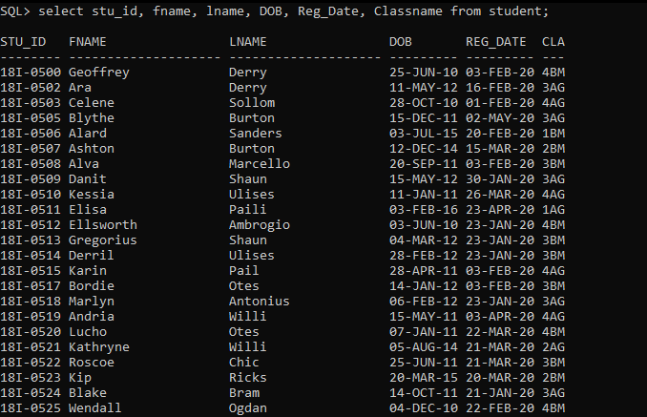

**Query 02:**

select mother.fname as "Mother Name", father.fname as "Spouse"  from parent mother, parent father where (mother.gender='F' AND father.spouse= mother.cnic); 

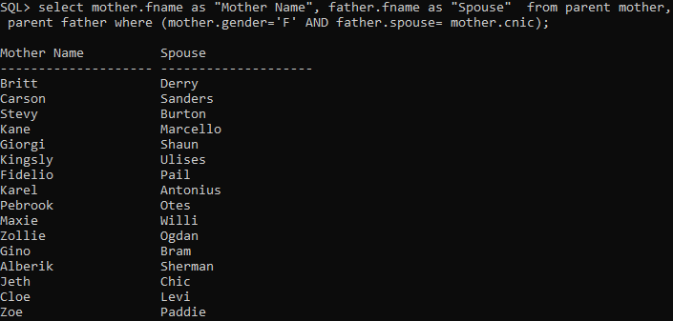

**Query 03:**

select g.name as “Guardian Name”, s.fname as “Student F_Name”, s.lname as “Student L_Name”, g.relation from student s, guardian g where s.guardian_cnic = g.cnic;

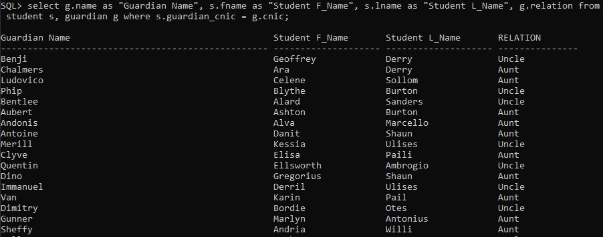

**Query 04:**

select s.fname as "Student Name", mother.fname as "Mother Name", father.fname as "Father Name"  from parent mother, parent father, student s where (mother.gender='F' AND father.spouse= mother.cnic AND s.father_cnic = father.cnic);

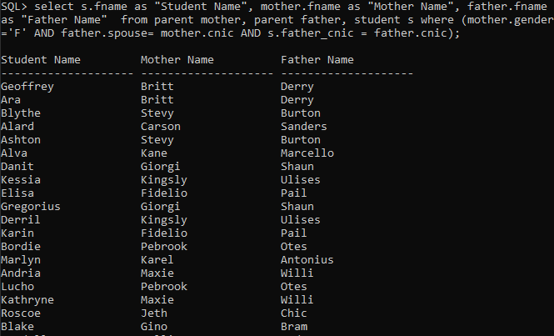

**Query 05:**

select distinct s1.stu_id, s1.fname,s1.lname,s1.classname from student s1,student s2 where s1.fname != s2.fname and s1.lname = s2.lname and s1.father_cnic = s2.father_cnic order by s1.lname;

(Siblings are displayed in order, have same father name).

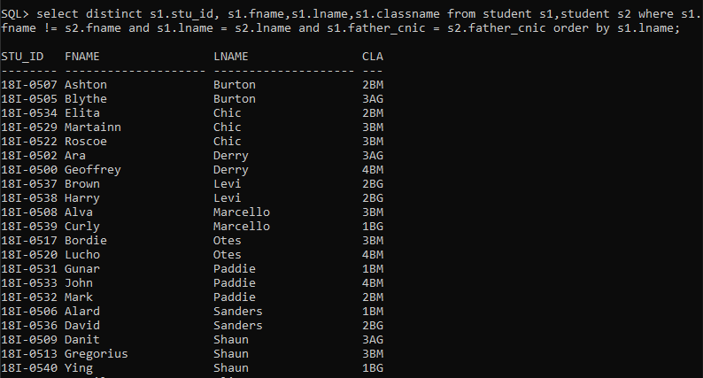

**Query 06:**

SELECT s.fname,s.lname, h.old_class, s.classname as New, s.reg_date from student s, class_history h where s.stu_id = h.stu_id and to_date(s.reg_date,'DD-MON-YYYY') >= to_date('14-FEB-19','DD-MON-YYYY') and to_date(s.reg_date,'DD-MON-YYYY') <= to_date('14-NOV-20','DD-MON-YYYY');

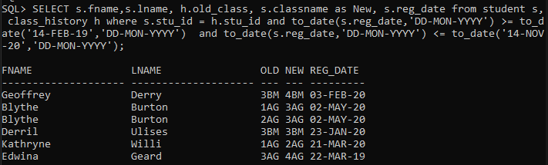

**Query 07:**

SELECT fname,lname,classname, reg_date from student  where to_date(reg_date,'DD-MON-YYYY') >= to_date('21-MAR-20','DD-MON-YYYY') and to_date(reg_date,'DD-MON-YYYY') <= to_date('14-JUL-20','DD-MON-YYYY');

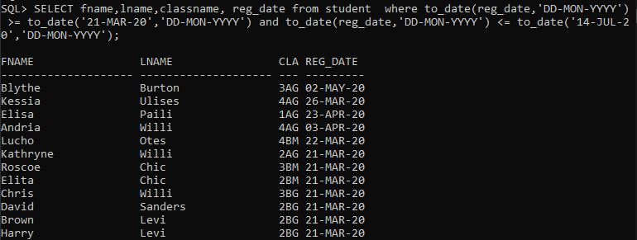

**Query 08:**

SELECT f.fname as "Parent Name", s.fname as "Student name", s.stu_id, s.classname, s.reg_date from student s, parent f where f.CNIC= s.FATHER_CNIC AND to_date(reg_date,'DD-MON-YYYY') >= to_date('21-MAR-20','DD-MON-YYYY') and to_date(reg_date,'DD-MON-YYYY') <= to_date('14-JUL-20','DD-MON-YYYY');

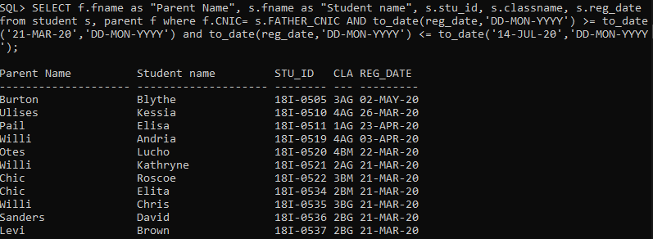

**Query 09:**

select p.fname as "Parent_Name", s.fname as "Student_Name", floor((s.reg_date - s.DOB)/365) as Child_Age, s.stu_id,s.classname from parent p,student s where p.cnic = s.father_cnic and (floor((s.reg_date - s.DOB)/365)) < 4;

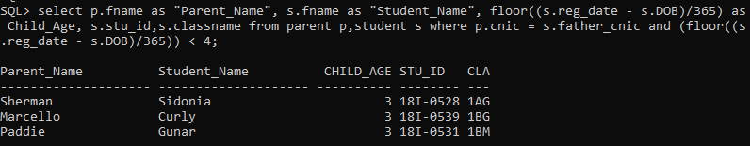

**Query 10:**

select stu_id, old_class, new_class from class_history where stu_id= '18I-0505';

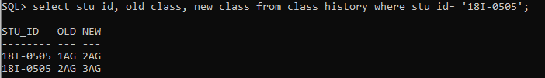

**(Preview of Reports 11-15)**

**Query 11:**

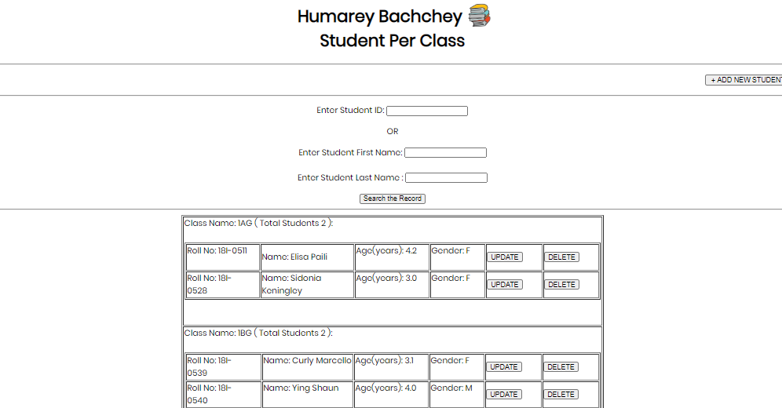

**Query 12:**

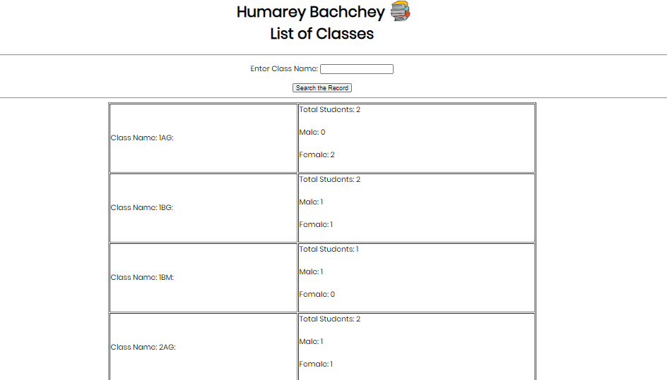

**Query 13:**

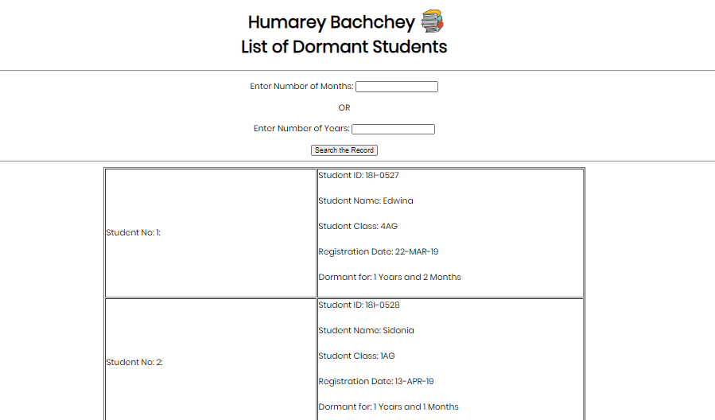

**Query 14:**

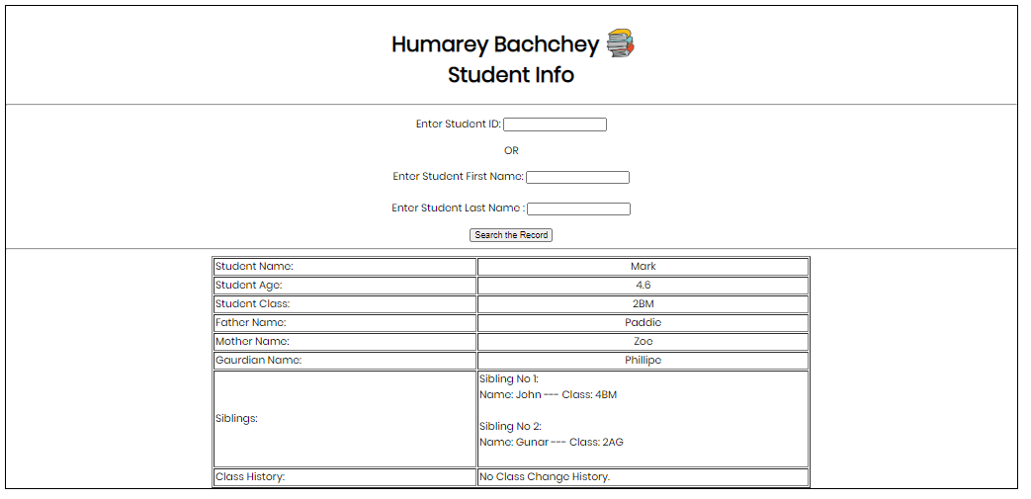

**Query 15:**

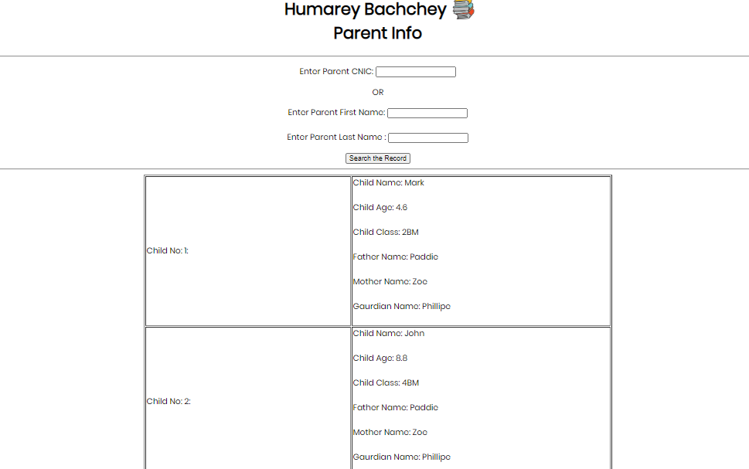

**Other Forms Preview:**

**Student Admission Form:**

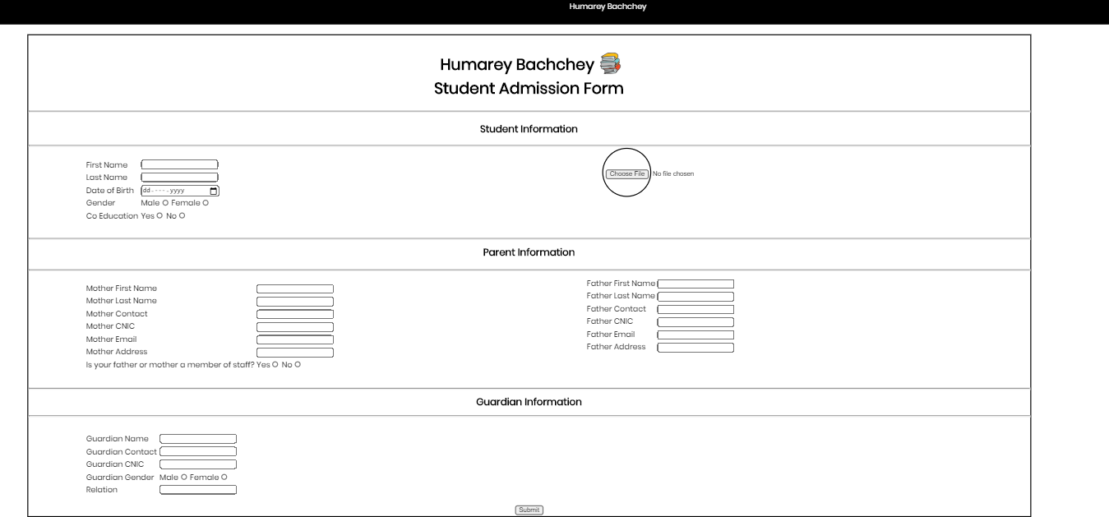

**Invoice:**

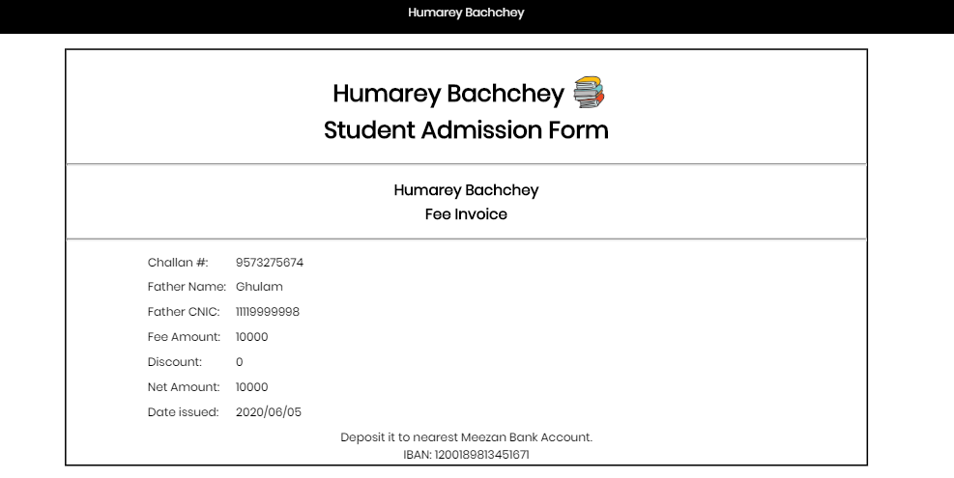

**Class Change:**

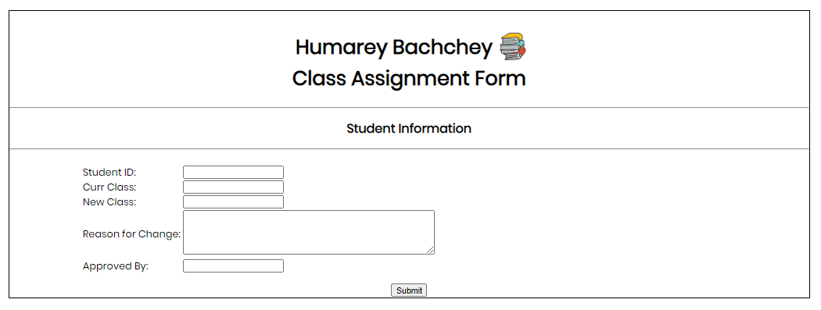

**Form to Check Fee Status:**

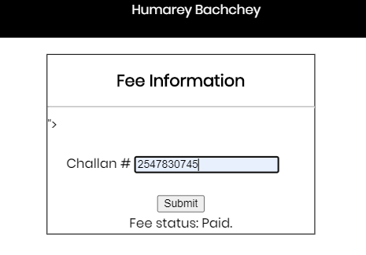

**Student Accompanying form:**

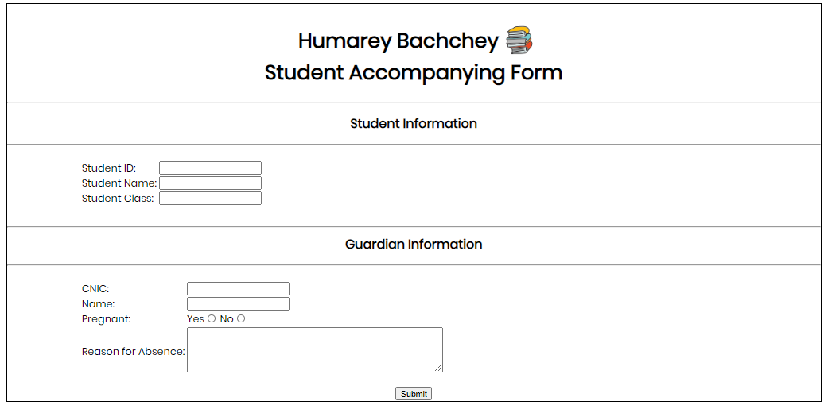

**Home Page:**



**NOTE: All forms/reports are available in (HTML_PHP_CSS folder), only change oracle SID and username/password in ‘dbh.php’ and it will work for all forms/reports. Also a Home page (‘homepage.html’) is available from where all forms/reports can be accessed.**